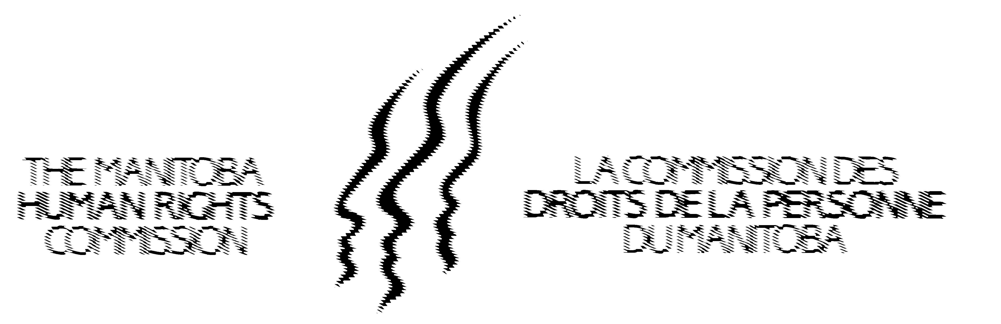


Association Manitobaine
des droits et libertés



Manitoba Association of
Rights and Liberties

September 30, 2008

Dear Friend;

Re: 2008 Manitoba Human Rights Commitment Awards
Call for Nominations

On behalf of the Human Rights Awards Committee, we are seeking nominations for the Annual Human Rights Commitment Award of Manitoba, and the Annual Sybil Shack Human Rights Youth Award. The nomination form, which has further information about the purpose of these awards, the criteria and nomination deadlines, is enclosed.

This year’s Commitment Award will recognize activities which have advanced human rights by promoting the rights of children. The Youth award will recognize a youth group or young person who has promoted respect for human rights and fundamental freedoms within Manitoba.

The deadline for nominations is Friday, November 7, 2008. The awards will be presented at a dinner to be held at the Fort Garry Hotel, Winnipeg, on December 10, 2008, International Human Rights Day in recognition and celebration of the 60th Anniversary of the Universal Declaration of Human Rights. The Awards Dinner follows a day long conference.

We would ask that you consider submitting a nomination, and would appreciate your circulating this Call for Nominations.

We thank you for your assistance and hope to see you on Wednesday, December 10, 2008.

Yours Sincerely,

Sherri Helgason Valerie Price Dianna Scarth
Director Executive Director Executive Director
Canadian Human Manitoba Association Manitoba Human
Rights Commission for Rights and Liberties Rights Commission

