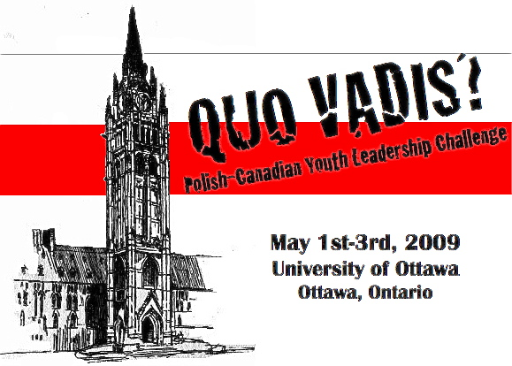

Our Patrons:
The Embassy of the Republic of Poland
The Canadian Polish Congress
The University of Ottawa Department of Modern Languages and Literatures

A kind request for sponsorship:
The Polish Students’ Society of the University of Ottawa (PSSUO) would like to inform you about an exciting event that we are organizing for Polish-Canadian Youth, from May 1st to the 3rd, 2009. This is the first time such an event is being held in Canada, and we would like to offer you the unique opportunity to take advantage of this one-of-a-kind Polonia event.

The “Quo Vadis – Polish-Canadian Youth Leadership Challenge” is the first Polish-Canadian young leaders conference in Ottawa and the first ever of its kind in terms of scale. It will bring together members of Polonia, both young and old from across the nation for a weekend of discussions, activities and events centered around three key concepts: heritage, leadership and unity. With the ends of reflecting on how young leaders can apply these three concepts to the preservation and enhancement of Polish culture in Canada.

We are not only expecting young leaders from across the country, but we are also looking forward to hosting some of Polonia’s most prominent members that weekend. We have received the unanimous support of the nation’s most important Polonia institutions and we are working closely with the Embassy of the Republic of Poland, the University of Ottawa and the Government of Canada to ensure the success of this event.

We are kindly inviting you to sponsor this one of a kind event, which is a great way for you to contribute and to and promote yourself – or business – within the community. The exposure you will receive during this event will be second to none. We encourage you to review the sponsorship packages to see which package you would benefit from the most.

All sponsors will receive appropriate acknowledgment throughout the event and recognition on the organizational website (www.pssuo.org). Additional promotion will be determined as per the way in which sponsors choose to contribute. Sponsors will also receive formal acknowledgment from the “Quo Vadis – Polish-Canadian Leadership Challenge” organizational committee for their generous support.

What you can expect in terms of promotion:
- Advertisement and Promotion access to difficult-to-reach Polonia demographic groups
- Nation-wide visibility: we expect strong interest from the media
- On-site marketing opportunities and visibility
- Advertising through official printed materials
- Right for logo for “Quo Vadis – Polish-Canadian Youth Leadership Challenge 2009” for one year as an official sponsor
- Other activities and properties are also available for partnership or sponsorship
If you wish to be our sponsor, we would encourage you to send us your logo to info@pssuo.org in either JPG or PDF file. Also, for inquiries about direct deposit into our bank account please contact us through email.

Cheques can be addressed to: “Polish Students’ Society of the University of Ottawa” and mailed to the following:

PSSUO: Polish-Canadian Student Youth Leadership Challenge
91 Glenhaven pvt.
Ottawa, ONT
K1V 2B2
Sincerely,

The Organizational Committee of the “Quo Vadis – Polish-Canadian Youth Leadership Challenge”

Email: info@pssuo.org

Sponsorship Packages

- Platinum Package ($1000+)
-Your name and logo will appear on all promotional materials (in larger print)
-You will be named as a chief sponsor in all advertisements (radio, television, promotional printed materials)
-You will receive a certificate of recognition and thanks from the organizational committee.
-Your contribution will be recognized at the opening and closing ceremonies of the convention.

- Gold Package ($500-$999)
-Your name and logo will appear on all promotional materials (in smaller print)
-You will receive a certificate of recognition and thanks from the organizational committee.
-Your contribution will be recognized at the opening and closing ceremonies.

- Silver Package ($200-$499)
-Your name will appear on all promotional materials (in smaller print)
-You will receive a certificate of recognition and thanks from the organizational committee.
-You will be recognized during opening ceremonies

- Bronze Package (up to $100)
-You will receive a certificate of recognition and thanks from the organizational committee.
-You will be recognized during opening ceremonies.
Other ways to support the Convention

Event Sponsorship:

- You or your company can sponsor individual events that will take place during the convention. During these events, you are free to advertise for your company and promote the service/product you provide.

- Should you choose to participate in this manner, you are required to provide the funds/material needs required to carry out this event.

- The following events can be sponsored:
River Boat Cruise
Dinners
Lunches

- Included in this sponsorship package are all the features of the Gold Sponsorship Package.

Prizes for the Leadership Challenge:

- Companies choosing to provide prizes* for the Leadership Convention Challenge winners will be announced and promoted at the “Evening at the Embassy”.
- Depending on the value of the prizes contributed by your organization, you will be also benefit from the promotion as offered by the afore-mentioned sponsorship packages (i.e.: prizes valued up to $100** will advertised as per the specifications listed under the Bronze Package)

*Please note that prizes must come in groups of five, as the Leadership Convention Challenge is a team effort, and all members of the team will be awarded an individual prize.
**Promotion packages will be determined by the total value of the all five prizes (i.e.: five prizes each valued at $100 will equal a total of $500, and will therefore boost your promotion package to the gold package)

Sponsorship Registration Form

Name of Organization: ________
Address: ________
________
________
Contact Person: ________
Phone: __________________________________
E-mail: __________________________________

Sponsorship Package: OR Alternative Sponsorship Method

□ Platinum Package ($1000+) □ Individual Event Sponsorship
□ Gold Package ($500-$999) Event you wish to sponsor:
□ Silver Package ($200-$499) □ Prize Sponsorship
□ Bronze Package (up to $100) Type of prizes:

Signature: Date:
-Cheques can be addressed to “The Polish Students’ Society of the University of Ottawa” and mailed to the following address:

PSSUO: Polish-Canadian Student Youth Leadership Challenge
91 Glenhaven pvt.
Ottawa, ONT
K1V 2B2

-For inquiries about direct deposit into our bank account please contact us through email.

Section for Organization Committee (do not fill out)
□ Payment received □ receipt issued
Method of Payment □ cheque □ money order □cash
Signing official (please print):
Signature:

