i

Weekend Long Tentative Schedule for
‘Quo Vadis? Polish-Canadian Youth Leadership Challenge’

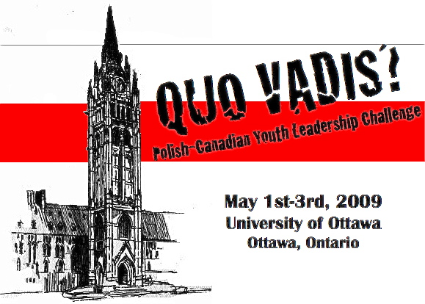

The Organizational Committee of the
“Quo Vadis – Polish-Canadian Youth Leadership Challenge”

Kamil Mroz Magdalena Sulzycka
Anna Barycka Carmela Ruta
Marta Janczerska Dr. R. Sokoloski

Contact Email: info@pssuo.org
Website: http://www.pssuo.org
Friday May 1st, 2009

Time | Scheduled Event
8:00-9:00 | Check in and Registration at the Lord Elgin Reception Desk  Students will be greeted by the Chief Executive Organizers and will be given information packages and showed to their rooms.
9:00-10:00
10:00-11:00
11:00-12:00
12:00-13:00
13:00-14:00
14:00-15:00
15:00-16:00 | Flag Raising Ceremony to commemorate the May 3rd Constitution  Day in Poland; a Collaboration with the Embassy of the Republic of Poland
16:00-17:00
17:00-18:00 | Opening Ceremony and Welcome Speeches  at The University of Ottawa  Plenary Speaker:  The Honorable Jesse Flis  Key Note Speakers:  His Excellency the Ambassador of Poland Piotr Ogrodziński  The Honorable Minister of Multiculturalism Jason Kenney  PSSUO and The executive organizers of the conference
18:00-19:00
19:00-20:00 | Dinner at SPK Dom Polski
20:00-21:00 | Dinner at SPK Dom Polski
21:00-22:00 | ‘Zabawa na Rzece’ Boat cruise
22:00-23:00 | ‘Zabawa na Rzece’ Boat cruise
23:00-24:00 | ‘Zabawa na Rzece’ Boat cruise
24:00-1:00 | ‘Zabawa na Rzece’ Boat cruise
1:00-1:30 | Back to Hotel

Saturday May 2nd

Time | Scheduled Event
7:00-8:00 | Breakfast at the Lord Elgin Hotel
8:00-9:00 | Breakfast at the Lord Elgin Hotel
9:00-10:00 | Surprise Group/Leadership Challenge
10:00-11:00 | Surprise Group/Leadership Challenge
11:00-12:00 | Surprise Group/Leadership Challenge
12:00-13:00 | Surprise Group/Leadership Challenge
13:00-13:45 | Back to Hotel to Freshen up for Panel Series and Leadership Workshop
14:00-18:00 | At The University of Ottawa  “Quo Vadis? Reflections on the Future”  Panel Series Discussion and Leadership Workshops
  Time | Event
  14:00 - 14:30 | Opening lecture by Polish Combatant
  14:30 - 16:15 | “Quo Vadis? Reflections on the Future”  Panel Series Discussion with:  - A Polish-Canadian representative of the Political Field  - A Polish-Canadian representative of the Media and Journalism  - A Political or Academic representative from Poland  - Polish-Canadian representative of the sciences and engineering  - A Polish-Canadian representative of the Business Sector  - A Polish-Canadian representative of the Military field
  16:15 - 16:30 | Coffee Break
  16:30 -18:00 | “Get involved, know Polonia Hands on Workshop”
18:00-19:00 | Dinner Break
19:00-20:00 | Dinner Break
20:00-21:00 | “An Evening in Poland”  Cocktails and Reception at the Embassy of the Republic of Poland
21:00-22:00
22:00-23:00
23:00-24:00 | “A Night on the Town in the Nation’s Capital”
24:00-1:00 | “A Night on the Town in the Nation’s Capital”
Sunday May 3rd, 2009

Time | Scheduled Event
7:00-8:00 | Breakfast at the Lord Elgin Hotel Conference Rooms
8:00-9:00 | Breakfast at the Lord Elgin Hotel Conference Rooms
9:00-10:00 | Free time
10:00-10:45 | Free time
11:00-12:30 | Ceremonial Mass at St. Hyacinth R.C. Polish Parish  Transportation departing from The Lord Elgin Hotel
12:30 – 14:30 | Lunch at the SPK Dom Polski
14:30 - 18:00 | Young Leaders Workshop followed by closing Ceremonies  “The Role of Young Leaders in Polonia”
  Time | Event
  14:30 -15:00 | PISK Presentation:  The Importance of Communication between Polonia Youth
  15:00 -16:15 | PSSUO Leadership Workshop:  A successful failure
  16:15 - 16:30 | Coffee Break
  16:30 - 18:00 | Closing Ceremonies and Student Reflections
18:00-19:00 | Departure
19:00-20:00 | Departure
20:00-21:00 | Departure

